40.54: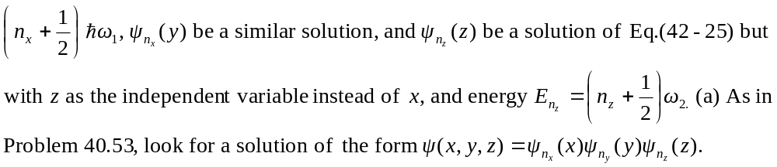
Then,
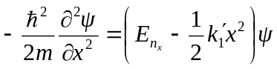
with similar relations for 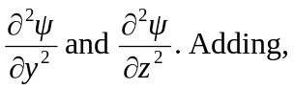
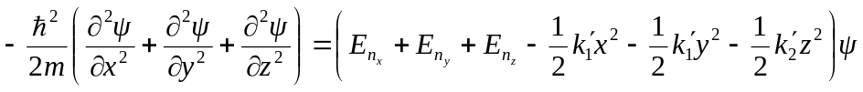
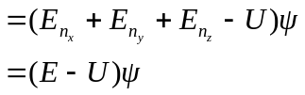
where the energy E is
